

AI-Based Sustainable Agriculture Management System
A CAPSTONE PROJECT REPORT

A Capstone Project Report submitted in partial fulfilment of the requirements for the
Course of

CSA0923 - PROGRAMMING IN JAVA
to the award of the degree of

BACHELOR OF ENGINEERING / BACHELOR OF TECHNOLOGY IN

Computer Science and Engineering (Artificial Engineering)

Submitted by
Y. Divya Sree (192472357)
R Geethika (192425101)
B Nikhila (192472102)
Under the Supervision of
Dr. Sarala V
SIMATS ENGINEERING
Saveetha Institute of Medical and Technical Sciences
Chennai-602105

SEPTEMBER 2026

SIMATS ENGINEERING

Saveetha Institute of Medical and Technical Sciences
Chennai-602105

BONAFIDE CERTIFICATE

This is to certify that the Capstone Project entitled “AI-Based Sustainable Agriculture Management System” has been carried out by Y. Divya Sree, R. Geethika, B. Nikhila under the supervision of Dr. Sarala V and is submitted in partial fulfilment of the requirements for the current semester of the B. Tech Computer Science and Engineering program at Saveetha Institute of Medical and Technical Sciences, Chennai.

COURSE COORDINATOR | COURSE FACULTY
Dr. G. Charlyn Pushpa Latha | Dr. Sarala V
Professor | Professor
Department of CSE | Department of CSE
Saveetha School of Engineering, | Saveetha School of Engineering,
SIMATS, Chennai – 602105. | SIMATS, Chennai – 602105.

SIMATS ENGINEERING

Saveetha Institute of Medical and Technical Sciences
Chennai-602105

DECLARATION
We, Y. Divya Sree, R. Geethika, B. Nikhila of the Computer Science and Engineering, SIMATS
Engineering, Saveetha Institute of Medical and Technical Sciences, Chennai, hereby declare that the Capstone Project Work entitled “AI-Based Sustainable Agriculture Management System” is the result of our own Bonafide efforts. To the best of our knowledge, the work presented herein is original, accurate, and has been carried out in accordance with the principles of engineering ethics and academic integrity. All sources, references, data, and other materials used in the project have been appropriately acknowledged. We further declare that the data, results, analysis, and findings presented in this report have not been fabricated, falsified, or manipulated. Any external tools, software, datasets, computational resources, or AI-assisted tools used during the project have been appropriately disclosed. We confirm that all applicable ethical, academic, institutional, and professional requirements have been duly followed throughout the planning, execution, analysis, and documentation of the project.

Place: Chennai
Date: 08-09-2026

Y. Divya Sree (192472357)

R Geethika (192425101)

B Nikhila (192472102)

SIMATS ENGINEERING

Saveetha Institute of Medical and Technical Sciences
Chennai-602105

INDIVIDUAL CONTRIBUTION STATEMENT

Student  Name /  Register No. | Specific  Responsibilities | Design &  Development  Contribution |  | Testing &  Analysis  Contribution | Report  Contribution | Approx  .  Contrib ution (%)
R.  Geethika  /  1924251  01 | Module 1 –  Priority-Based  Farm Task  Management | Designed and implemented the priority-based task management module using priority queue logic |  | Tested task prioritization and selection of high-priority tasks | Contributed  to report  preparation and documentation n | 33%
B.  Nikhila /  1924721  02 | Module 3 –  Task Completion and  Performance  Monitoring | Designed implemented completion performance monitoring functionality | and task and | Tested task status updates, completed/pending task counting, and performance monitoring | Contributed  to report  preparation and documentation | 33%
Y. Divya Sree /  1924723  57 | Module 2 –  Farm  Condition  Analysis;  Website  Design &  Development;  PPT  Preparation and  Presentation  Support | Designed and developed the website and implemented Module 2 using conditional decision logic |  | Tested farm data entry, condition analysis, task recommendations, and result display | Contributed  to report  preparation,  PPT  preparation, and presentation | 34%

ABSTRACT

Agriculture involves several decisions related to crop selection, soil conditions, water management, crop health, and weather conditions. Making these decisions manually can be difficult because multiple farm conditions need to be considered together. The project “AI-Based Sustainable Agriculture Management System” proposes a software-based decision-support system that helps organize farm information and generate suitable farm-management tasks based on the entered conditions.
The proposed system accepts farm-related inputs such as crop, soil type, soil moisture, weather condition, and crop health. The system uses three main modules. Module 1, Priority-Based Farm Task Management, uses a Priority Queue to arrange tasks according to their importance, with high-priority tasks handled before medium- and low-priority tasks. Module 2, Conditional Decision Logic-Based Farm Condition Analysis, uses IF-ELSE decision logic to analyse the entered farm conditions. For example, low soil moisture generates an irrigation task with high priority, while poor crop health generates a disease-monitoring task. Rainy weather can also generate a disease-monitoring task. Module 3, Task Completion and Performance Monitoring, tracks task status and distinguishes between pending and completed tasks.
The system is implemented using Java-based programming concepts with a web interface. Farm and task information can be stored and retrieved through the system so that the dashboard reflects user entered information rather than fabricated values. The project focuses on providing a simple and understandable decision-support workflow while encouraging efficient use of agricultural resources. The implemented system demonstrates how basic AI-oriented decision support, priority-based task management, and task monitoring can be combined into a single sustainable agriculture management application. The present prototype is primarily based on defined decision rules and does not claim trained machine-learning accuracy. Future development can integrate real-time IoT sensors, weather APIs, machine-learning models, disease-image analysis, and advanced analytics.
Keywords: Sustainable Agriculture, Decision Support System, Priority Queue, IF-ELSE Logic, Farm
Management, Artificial Intelligence.

TABLE OF CONTENTS

Sl.  No | Title | Page  No
i | CERTIFICATE FROM THE SUPERVISOR | i
ii | DECLARATION BY THE CANDIDATE | ii
iii | INDIVIDUAL CONTRIBUTION STATEMENT | iii
iv | ABSTRACT | iv
v | LIST OF FIGURES | v
vi | LIST OF TABLES | vi
vii | LIST OF ABBREVIATIONS / SYMBOLS | vii
1 | CHAPTER 1: INTRODUCTION AND ENGINEERING PROBLEM | 10–12
2 | CHAPTER 2: LITERATURE REVIEW AND EXISTING SOLUTIONS | 13–14
3 | CHAPTER 3: ENGINEERING DESIGN & TRADE-OFFS,  SUSTAINABILITY, ETHICS, SAFETY, RISK & SECURITY | 15–20
4 | CHAPTER 4: IMPLEMENTATION, TESTING & RESULTS, PROJECT  MANAGEMENT | 21-25
5 | CHAPTER 5: CONCLUSION, FUTURE WORK AND REFLECTION | 26- 27
 | REFERENCES | 28
 | APPENDICES | 29-33

LIST OF FIGURES

Figure No. | Figure Name | Page No.
Figure 1 | System Architecture and Workflow | 27
Figure 2 | Website / Home Dashboard | 18
Figure 3 | Farm Data Input Interface | 19
Figure 4 | Module 2 Farm Condition Analysis Output | 20
Figure 5 | Priority-Based Task Management Output | 21
Figure 6 | Task Completion and Performance Dashboard | 22

LIST OF TABLES

Table No. | Table Name | Page No.
Table 1 | Functional Requirements | 15
Table 2 | Design Specifications | 16
Table 3 | Alternative Solutions Evaluation | 16
Table 4 | Sustainability, Ethics, Safety, Risk and Security Analysis | 17
Table 5 | Risk Register | 17
Table 6 | Software Resources Used | 18
Table 7 | Software Tools and Modern Technologies Used | 19
Table 8 | Achievement of Project Objectives | 21
Table 9 | Project Milestones | 22
Table 10 | Team Roles and Contributions | 23

LIST OF ABBREVIATIONS / SYMBOLS

Abbreviation / Symbol | Description
AI | Artificial Intelligence
IoT | Internet of Things
UI | User Interface
DB | Database
IF-ELSE | Conditional Decision Logic
PQ | Priority Queue

CHAPTER 1
INTRODUCTION AND ENGINEERING PROBLEM

1.1 Background
Agriculture is an important sector that depends on several interacting factors such as soil condition, water availability, weather, crop type, and crop health. Farmers need to make timely decisions regarding irrigation, crop monitoring, and other farm activities. When these decisions are managed manually, it may become difficult to organize tasks and respond to changing farm conditions efficiently.
The development of digital agriculture systems provides an opportunity to support farmers through data-based decision making. An agriculture management system can collect relevant farm information, analyse the entered conditions, and provide appropriate recommendations or tasks. The proposed AI-Based Sustainable Agriculture Management System is designed as a softwarebased decision-support application. It combines farm-condition analysis, priority-based task management, and task completion monitoring. The system uses defined decision rules to analyse farm conditions and a Priority Queue to ensure that important tasks are addressed first.

1.2 Need for the Project
The project is needed because agricultural decisions often involve multiple conditions at the same time. In particular, soil moisture, weather, and crop health can affect the actions required on a farm.
The major needs addressed by the project are:
- To simplify farm-condition analysis.
- To identify important farm tasks from entered conditions.
- To prioritize urgent tasks.
- To reduce unnecessary or unplanned resource usage.
- To maintain task status in an organized manner.
- To provide a simple dashboard for monitoring farm activities.
- To support sustainable use of agricultural resources.
Farmers and farm managers are the primary users who can benefit from organized decision support. From an engineering perspective, the project demonstrates the integration of decision logic, data management, task prioritization, and monitoring into one software system.

1.3 Problem Statement
Farm management requires decisions based on multiple interacting conditions such as crop type, soil type, soil moisture, weather, and crop health. Manual analysis of these conditions can make it difficult to identify urgent tasks and monitor their completion.
Therefore, the engineering problem is to develop a software-based agriculture management system that accepts farm-condition information, analyses it using defined decision logic, generates appropriate tasks, prioritizes important tasks, and tracks task completion without using fabricated farm data.

1.4 Project Aim
The aim of this project is to develop an AI-Based Sustainable Agriculture Management System that supports farm-condition analysis, task prioritization, and performance monitoring using softwarebased decision-support techniques.

1.5 Project Objectives
- To design a software system for organizing agricultural information.
- To develop a web-based interface for entering and viewing farm information.
- To analyse farm conditions using IF-ELSE decision logic.
- To generate suitable farm-management tasks based on entered conditions.
- To prioritize generated tasks using a Priority Queue.
- To track pending and completed farm tasks.
- To provide a dashboard for monitoring task status.
- To avoid fabricated values and display information based on actual user-entered data.
- To support sustainable decision making related to agricultural resource management.

1.6 Scope Included
- Farm information entry.
- Crop, soil, moisture, weather, and crop-health analysis.
- Rule-based farm-condition decision support.
- Priority-based task management.
- Task status tracking.
- Dashboard-based monitoring.
- Storage and retrieval of entered farm/task information.

Excluded
- Real-time agricultural sensor hardware.
- Automatic physical irrigation control.
- Actual pesticide or fertilizer application.
- Guaranteed disease diagnosis.
- A trained machine-learning model unless separately integrated.
- Replacement of professional agricultural advice.

Assumptions
- Users enter meaningful and valid farm information.
- The decision rules are based on the conditions defined for the project.
- The system operates using the available software environment.

Boundary Conditions
The system provides software-based decision support. It does not directly control agricultural equipment or guarantee crop outcomes.

1.7 Expected Engineering Outcome
The expected outcome is a functional prototype of an agriculture management system that:
- Accepts farm-condition information.
- Analyses the entered information.
- Generates relevant farm tasks.
- Assigns priority to important tasks.
- Tracks task completion.
- Displays the current task status.
- Stores actual user-entered information.
- Provides a foundation for future IoT and machine-learning integration.

CHAPTER 2
LITERATURE REVIEW AND EXISTING SOLUTIONS

2.1 Review Method
The literature review was carried out using recent research related to artificial intelligence in agriculture, sustainable agriculture, machine learning, IoT-based agricultural systems, and digital agricultural decision support. The reviewed studies were used to understand existing approaches, their benefits, limitations, and the engineering gap addressed by the proposed system.

2.2 Review of Existing Work AI for Sustainable Agriculture
Recent research has investigated the use of Artificial Intelligence for improving agricultural productivity and sustainability. AI-based methods can support crop production, resource management, monitoring, and agricultural decision making.

AI and IoT for Soil Management
AI and IoT-based approaches can combine sensor information with intelligent analysis for soil and nutrient management. Such systems provide opportunities for more precise agricultural resource management.

Machine Learning in Agriculture
Machine-learning techniques have been studied for applications such as crop prediction, disease detection, yield prediction, and agricultural monitoring. These approaches can provide predictive capabilities when suitable datasets and trained models are available.

Digital Agriculture and Decision Support
Digital agricultural systems can assist users by organizing farm data and providing recommendations based on available information. However, system complexity, sensor requirements, data availability, and implementation cost can affect practical adoption.

2.3 Comparative Analysis

Existing  Approach | Advantages | Limitations | Relevance to  Proposed Work
Manual Farm  Management | Simple and familiar | Time-consuming and difficult to prioritize tasks | Problem addressed by proposed system
AI-Based  Agriculture | Can support intelligent decision making | May require datasets and trained models | Provides future  direction
IoT-Based  Agriculture | Provides real-time sensor information | Requires hardware and sensor infrastructure | Considered as future enhancement
Proposed System | Simple decision support, task prioritization and monitoring | Current prototype uses defined decision rules | Directly supports  project objectives

2.4 Research / Engineering Gap
Existing agricultural technologies provide different capabilities such as prediction, monitoring, sensor-based data collection, and intelligent analysis. However, a lightweight system that combines farm-condition decision logic, priority-based task management, and task completion monitoring can provide a simpler workflow for academic and prototype-level implementation.
The proposed project addresses this gap by integrating these functions into a single system. The current implementation focuses on rule-based decision support rather than claiming predictive machine-learning performance.

2.5 Proposed Contribution
The proposed system contributes a simple software-based framework for sustainable agriculture management. Its main contribution is the integration of:
- Farm-condition analysis.
- IF-ELSE based decision logic.
- Priority Queue based task management.
- Task completion tracking.
- Dashboard-based performance monitoring.
The system also follows the project requirement of displaying actual user-entered information rather than fabricated results.

CHAPTER 3
ENGINEERING DESIGN, TRADE-OFFS, SUSTAINABILITY, ETHICS, SAFETY, RISK
AND SECURITY

3.1 Requirements

3.1.1 Stakeholder Requirements
The primary stakeholder is the farmer or farm user who requires a simple method for understanding farm conditions and organizing agricultural tasks.
The system should:
- Accept basic farm and crop information.
- Analyse entered conditions.
- Generate appropriate farm tasks.
- Identify high-priority activities.
- Allow users to monitor task status.
- Store farm and task information.
- Present information clearly through a web interface.
3.1.2 Functional Requirements
Requirement ID | Functional Requirement
FR1 | The system shall accept farm and crop information.
FR2 | The system shall accept soil-moisture information.
FR3 | The system shall accept weather and crop-health information.
FR4 | The system shall analyse entered conditions.
FR5 | The system shall generate suitable farm tasks.
FR6 | The system shall assign task priorities.
FR7 | The system shall display pending and completed tasks.
FR8 | The system shall store relevant information in the database.
FR9 | The system shall provide performance-monitoring information.

3.1.3 Non-Functional Requirements
- Usability: The interface should be simple and understandable.
- Reliability: The system should generate consistent results for the same inputs.
- Performance: The system should provide analysis without unnecessary delay.
- Maintainability: The modular structure should allow individual modules to be modified.
- Security: User-entered data should be handled securely.
- Scalability: The system should allow future integration of additional agricultural parameters.
- Data Integrity: Stored information should remain consistent with user actions.
3.2 Constraints and Applicable Standards

Constraints
- The current system is primarily software-based.
- Real-time IoT sensors are not included in the current implementation.
- The current decision-making module uses predefined conditional rules.
- The quality of recommendations depends on the correctness of user-provided information.
- The system is intended as a decision-support prototype rather than a fully automated agricultural control system.

Applicable Software Practices
The project follows software-quality considerations related to usability, reliability, performance, maintainability, and security. Web-security practices should be considered when handling user input and database operations.

3.3 Design Specifications
Component | Specification
Input | Crop, soil type, soil moisture, weather, crop health
Decision Method | IF-ELSE conditional logic
Task Prioritization | Priority Queue
Priority Levels | HIGH, MEDIUM, LOW
Priority Values | HIGH = 3, MEDIUM = 2, LOW = 1
Task States | PENDING, COMPLETED
Database | Lightweight database for farm/task records
Interface | Web-based interface
Core Language | Java
Output | Recommended and prioritized farm tasks
3.4 Alternative Solutions and Evaluation
Three possible approaches were considered.

Alternative 1 – Manual Farm Management
Farmers manually observe farm conditions and decide which activity to perform.
Advantages: Simple and inexpensive.
Limitations: Highly dependent on human observation, difficult to prioritize multiple tasks, and difficult to maintain digital records.

Alternative 2 – Full IoT-Based Smart Agriculture System
Sensors continuously collect soil and environmental information and transmit the data to an application.
Advantages: Real-time data collection and automation.
Limitations: Requires hardware, sensors, connectivity, maintenance, and higher implementation cost.

Alternative 3 – Software-Based Decision Support System
The system accepts farm conditions, analyzes them using decision logic, prioritizes tasks, and tracks completion.
Advantages: Lower complexity, easier implementation, simple user interaction, and suitable for a prototype.

Evaluation
Criterion | Manual System | IoT System | Proposed System
Implementation complexity | Low | High | Moderate
Hardware requirement | Low | High | Low
Cost | Low | High | Low
Task prioritization | Low | Medium/High | High
Data management | Low | High | High
Scalability | Low | High | High
Suitability for prototype | High | Medium | High
The proposed system was selected because it provides a balance between functionality, implementation complexity, cost, and future expandability.
3.5 Selected Design and Detailed Design
The selected design consists of three interconnected modules.

Overall System Flow
User Input → Farm Condition Analysis → Task Generation → Priority Assignment → Task
Management → Completion Tracking → Performance Dashboard

Module 1: Priority-Based Farm Task Management
This module uses a Priority Queue. Each generated task is assigned a priority value:
- HIGH = 3
- MEDIUM = 2
- LOW = 1
The task with the highest priority is selected before lower-priority tasks. Module 2: Conditional Decision Logic-Based Farm Condition Analysis
This module analyses the farm conditions using IF-ELSE logic.
The major rules are:
- If soil moisture is low → generate irrigation task with HIGH priority.
- If crop health is poor → generate disease-monitoring task with HIGH priority.
- If weather is rainy → generate disease-monitoring task.
This module converts input conditions into actionable farm tasks.

Module 3: Task Completion and Performance Monitoring
All generated tasks initially have a PENDING status. When the user completes a task, its status changes to COMPLETED.
The system can then determine:
- Number of completed tasks.
- Number of pending tasks.
- Number of high-priority pending tasks.
- Overall task status.

3.6 Trade-Off Analysis
The main engineering trade-off was between system simplicity and advanced automation.
A fully automated IoT-based system could provide real-time environmental data but would require additional hardware and communication infrastructure. The proposed software-based approach reduces implementation complexity while still demonstrating decision support and task management.
Similarly, predefined IF-ELSE rules are easier to understand and implement than a trained machinelearning model. However, machine-learning models could provide more advanced prediction when sufficient real-world datasets become available.
The selected design therefore prioritizes simplicity, transparency, maintainability, and future extensibility.

3.7 Sustainability, Ethics, Safety, Risk and Security
Domain | Consideration | Evidence/Approach | Impact
Sustainability | Reduce unnecessary  resource usage | Condition-based irrigation recommendation | Supports efficient water usage
Sustainability | Improve task  organization | Priority-based task  management | Supports timely farm activities
Ethics | Responsible recommendations | System acts as decision  support | Reduces over-reliance on automation
Data Privacy | Protect farm information | Controlled database access | Reduces unauthorized access
Safety | Avoid automatic  physical control | Software recommendations only | Reduces physical  equipment risk
Reliability | Consistent decision rules | Defined IF-ELSE conditions | Improves predictable behaviour
Security | Validate user inputs | Input validation and safe database operations | Reduces data-related risks

Risk Register
Risk | Likelihood | Severity | Risk Level | Mitigation | Residual  Risk
Incorrect user input | Medium | Medium | Medium | Input validation | Low/Medium
Incorrect rule implementation | Low/Medium | High | Medium | Functional testing | Low
Database failure | Low | Medium | Low/Medium | Proper database handling and backup | Low
Unauthorized data access | Low | High | Medium | Access control and secure  queries | Low
Dependence on  predefined rules | Medium | Medium | Medium | Future ML  integration | Medium
Lack of real-time sensor data | High | Medium | Medium | Future IoT  integration | Medium

CHAPTER 4

IMPLEMENTATION, TESTING & RESULTS, PROJECT MANAGEMENT

4.1 Development Approach & Resources
The project was developed using a modular approach. The system requirements were first identified and then divided into farm-condition analysis, task prioritization, and task monitoring modules. The web interface was developed to allow users to enter and view farm information, while the application logic processes the entered conditions and generates tasks. The modules were then integrated into the overall agriculture management workflow.

Resources Used
Resource | Purpose
Java | Application logic and implementation
Web technologies | User interface development
Database | Storage and retrieval of farm/task information
Development environment | Coding and testing
AI-assisted development tools, where used | Development support

4.2 Software Implementation & Modern Tools Used User Interface
The website provides interfaces for entering farm information and viewing generated tasks and task status.

Decision Logic
The system analyses:
- Crop
- Soil type
- Soil moisture
- Weather
- Crop health
The entered values are processed through the defined IF-ELSE rules.

Priority Management
Generated tasks are assigned priority levels and managed using the Priority Queue implemented in Module 1.

Task Monitoring
The task-monitoring module records whether tasks are pending or completed and provides corresponding counts. Tools
Tool / Software | Purpose | Stage Used
Java | Application and algorithm implementation | Development
HTML/CSS/JavaScript or implemented web technologies | Website interface | Development
Database | Data storage | Development
Development IDE/environment | Coding and debugging | Development
AI-assisted development tool, if used | Development assistance | Development
Implementation Evidence:
[Insert actual website screenshots here] Suggested figures to insert:
- Figure 1: Home/Dashboard page
- Figure 2: Farm information input page
- Figure 3: Module 2 condition analysis output
- Figure 4: Priority-based task list
- Figure 5: Task completion dashboard

4.4 Results
The implemented system is designed to generate outputs based on actual farm information entered by the user. The system does not require fabricated farm values for displaying dashboard information.
The main functional outputs include:
- Farm-condition analysis.
- Irrigation task generation when the defined low-moisture condition occurs.
- Disease-monitoring task generation for the defined crop-health and weather conditions.
- Priority-based ordering of generated tasks.
- Pending and completed task tracking.
- Dashboard-based task monitoring.

Results Evidence
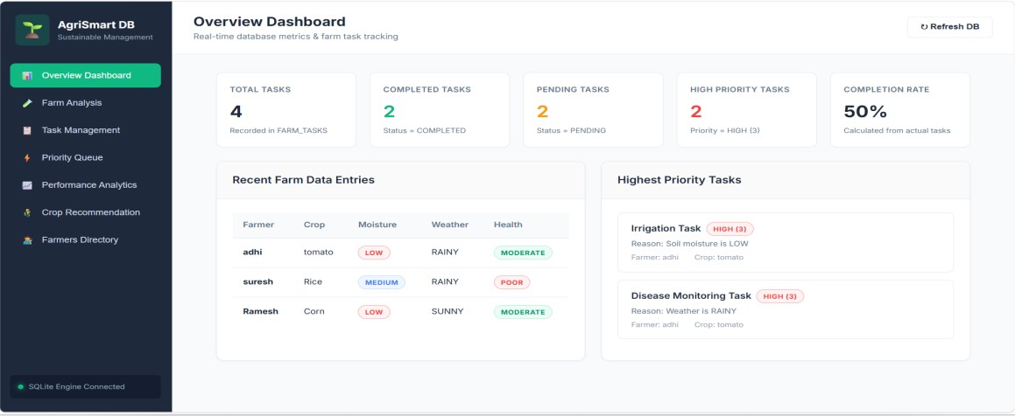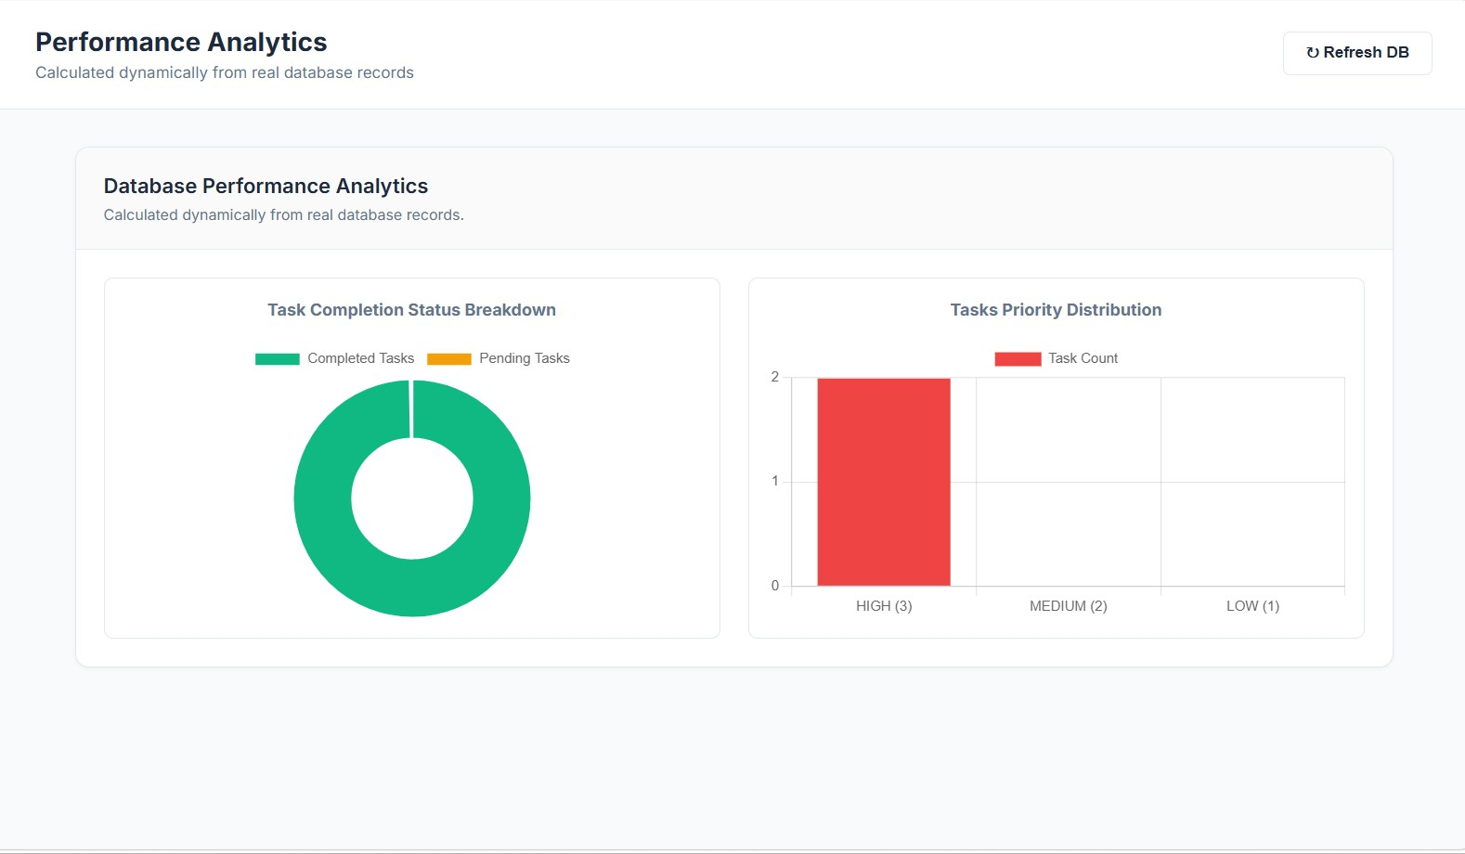

4.5 Data Analysis & Engineering Judgment
The system output is determined by the defined decision rules and the values entered by the user. The use of explicit IF-ELSE conditions makes the decision process transparent and easy to verify. The Priority Queue ensures that tasks assigned higher priority are considered before lower-priority tasks. An important engineering decision was to avoid displaying fabricated dashboard values. This ensures that task counts and farm records represent actual system data. Since the current system uses predefined decision rules, the project should not claim machine-learning accuracy or predictive performance without an independently trained and tested model.

4.6 Comparison with Existing Solutions & Achievement of Objectives
Objective | Evidence | Achievement
Design agriculture management system | Overall system architecture and modules | [Fully]
Develop web interface | Implemented website | [Fully]
Analyse farm conditions | Module 2 IF-ELSE logic | [Fully]
Generate farm tasks | Condition-based task generation | [Fully]
Prioritize tasks | Module 1 Priority Queue | [Fully]
Track task completion | Module 3 task status tracking | [Fully]
Monitor performance | Dashboard/task counts | [Fully]
Avoid fabricated values | Dynamic user-entered information | [Fully]

4.7 Strengths & Limitations Strengths
- Simple and understandable user interface.
- Modular system design.
- Uses Priority Queue for task prioritization.
- Uses transparent IF-ELSE decision logic.
- Provides task completion monitoring.
- Supports organized farm-data management.
- Avoids fabricated dashboard information.
- Provides a foundation for future AI and IoT integration.

Limitations
- Current decision support is based on predefined rules.
- The system depends on user-entered information.
- Real-time IoT sensor integration is not included in the current prototype.
- Real-time weather API integration is not included unless separately implemented.
- No machine-learning accuracy should be claimed without actual model training and validation.
- The system does not directly control irrigation or other physical agricultural equipment.

4.8 Project Planning, Roles & Budget Project Milestones
Phase | Activity
Phase 1 | Problem identification and requirement analysis
Phase 2 | Literature review
Phase 3 | System design
Phase 4 | Module development
Phase 5 | Website development
Phase 6 | Module integration
Phase 7 | Testing and debugging
Phase 8 | Documentation and presentation

Team Roles
Student | Assigned  Responsibility | Actual Contribution
R Geethika –  192425101 | Module 1 | Priority-Based Farm Task Management
B Nikhila –  192472102 | Module 3 | Task Completion and Performance Monitoring
Y Divya Sree –  192472357 | Module 2 + Website  + PPT | Conditional Decision Logic-Based Farm Condition  Analysis, website development and PPT preparation

CHAPTER 5

CONCLUSION, FUTURE WORK AND REFLECTION
5.1 Conclusion
The AI-Based Sustainable Agriculture Management System was developed to provide software-based decision support for agricultural task management. The system combines farm-condition analysis, priority-based task management, and task completion monitoring.
Module 1 uses a Priority Queue to arrange tasks according to their importance. Module 2 uses IF-ELSE decision logic to analyse soil moisture, crop health, and weather conditions and generate appropriate tasks. Module 3 tracks task completion and provides information about pending and completed tasks.
The project demonstrates that a modular software system can organize farm information and support structured agricultural decision making. The current system is intentionally presented as a decision-support prototype based on defined rules and does not claim trained machine learning accuracy. The system also emphasizes the use of actual user-entered information rather than fabricated dashboard values.
5.2 Future Work
The following improvements can be considered for future development:
- Integration of IoT sensors for real-time soil and environmental data.
- Integration of real-time weather information.
- Development of machine-learning models for crop and disease prediction.
- Image-based crop disease detection.
- Advanced crop recommendation systems.
- Automated irrigation monitoring and control.
- Mobile application development.
- Multilingual support for farmers.
- Cloud-based data storage and remote access.
- Advanced analytics and visualization.
- Integration of historical farm data for predictive decision support.
5.3 Professional Learning & Individual Reflection
New Knowledge Acquired
- Understanding of software-based agricultural decision support.
- Practical use of IF-ELSE decision logic.
- Understanding of Priority Queue based task management.
- Website development and interface design.
- Understanding of database-based information management.
- Technical documentation and presentation preparation.
Engineering & Professional Skills Developed
- Problem analysis.
- Modular software design.
- Web development.
- Algorithm implementation.
- Debugging and testing.
- Team coordination.
- Technical documentation.
- Technical presentation.
Individual Reflection – Y Divya Sree
My main contribution to the project was website development, Module 2 implementation, and PPT preparation. The most difficult part was connecting the farm-condition inputs with the appropriate decisions while keeping the system simple and understandable. I solved this by organizing the conditions into clear IF-ELSE rules and connecting them with the required task generation. I independently developed my understanding of the website interface and decision-logic implementation. If I redesigned the project, I would further improve the interface and integrate real-time weather and IoT data.

REFERENCES
- A. Sabharwal and S. R. N. Reddy, “Advancing Sustainable Agriculture: Integrating AI and IoT for Soil Nutrient Management—A Systematic Review,” Soil Use and Management, Wiley, 2026.
- A. K. M. Pervez, M. S. Kabir, F. A. Prodhan, et al., “Mapping Recent Trends in Artificial Intelligence Research for Sustainable Agriculture: A Bibliometric and Systematic Review,” Discover Artificial Intelligence, Springer, 2026.
- Z. Ali, A. Muhammad, N. Lee, M. Waqar, and S. W. Lee, “Artificial Intelligence for Sustainable
Agriculture: A Comprehensive Review of AI-Driven Technologies in Crop Production,”
Sustainability, vol. 17, no. 5, p. 2281, 2025.
- V. Subashini, N. Sriram, and C. Karthikeyan, “Application of Artificial Intelligence in Agriculture and Allied Sectors: A Comprehensive Review Towards Sustainable Solutions,” Plant Science Today, 2025.
- Aashu, K. Rajwar, M. Pant, and K. Deep, “Application of Machine Learning in Agriculture:
Recent Trends and Future Research Avenues,” arXiv, 2024.
- Oracle, “Java Documentation,” Oracle.
- OWASP Foundation, “OWASP Top 10 Web Application Security Risks.”
- International Organization for Standardization, “ISO/IEC 25010: Systems and Software
Engineering — Systems and Software Quality Requirements and Evaluation (SQuaRE
) — Product Quality Model.”
- World Wide Web Consortium, “Web Content Accessibility Guidelines (WCAG) 2.2.”
Note: Add the actual URLs, access dates, software versions, datasets, repositories, and AI-assisted development resources that were actually used in your project. Do not add resources that you did not use.

APPENDICES

Appendix A – System Architecture and Workflow
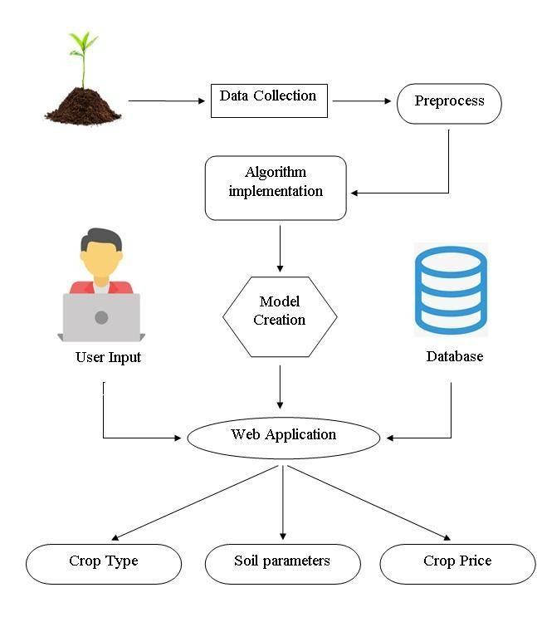
User Input → Farm Condition Analysis → Task Generation → Priority Queue → Task Status → Dashboard
Appendix B – Source Code / Implementation Evidence
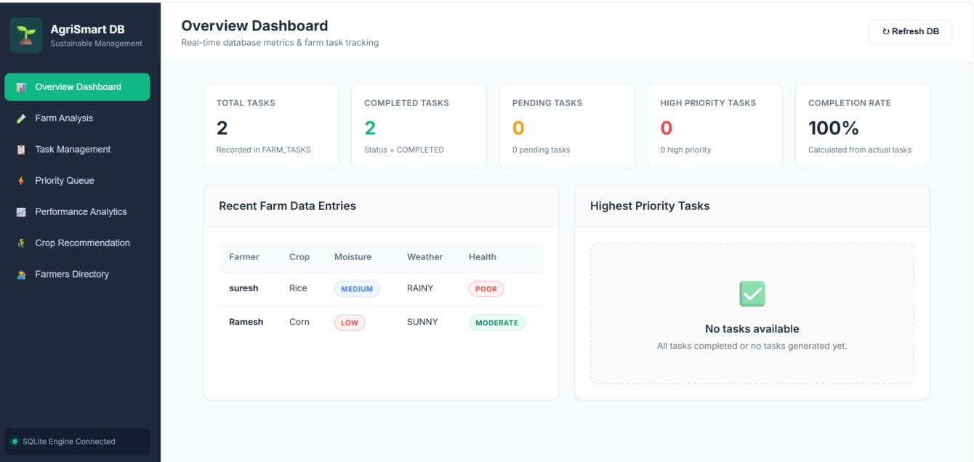
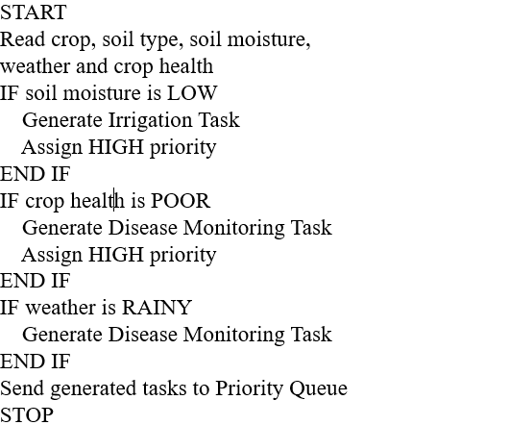
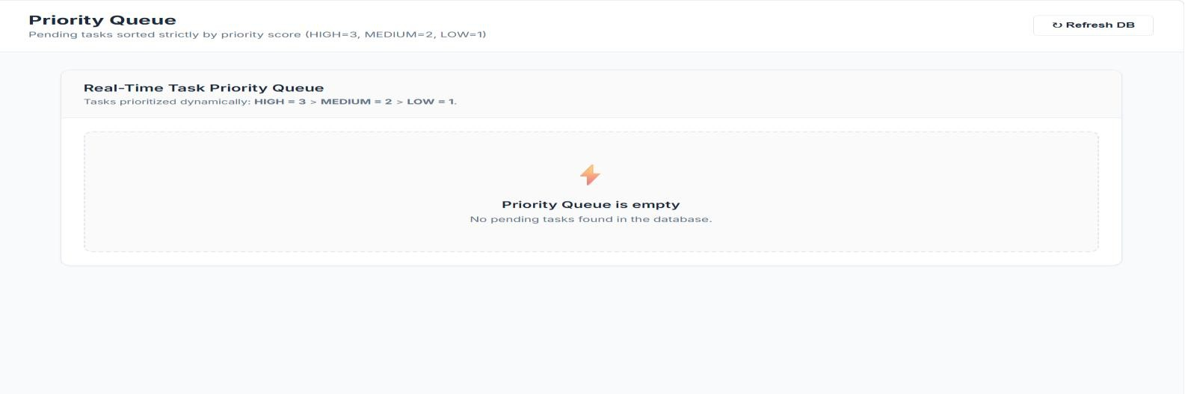
Appendix C – Testing Evidence
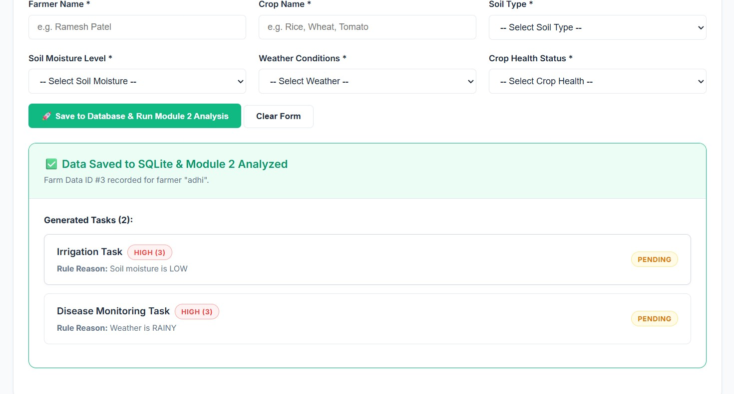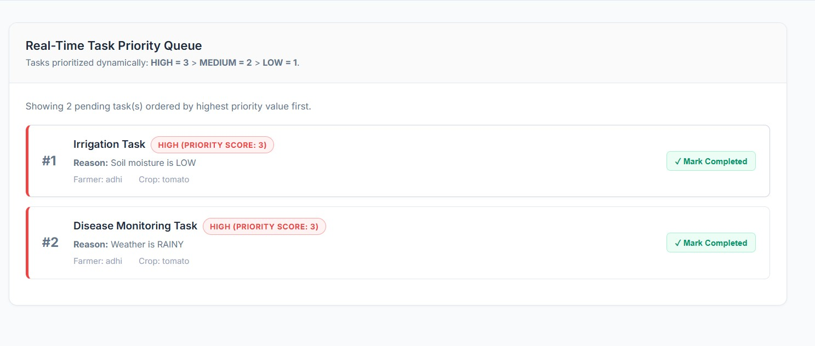
Appendix D – Individual Contribution Evidence
Y Divya Sree – 192472357

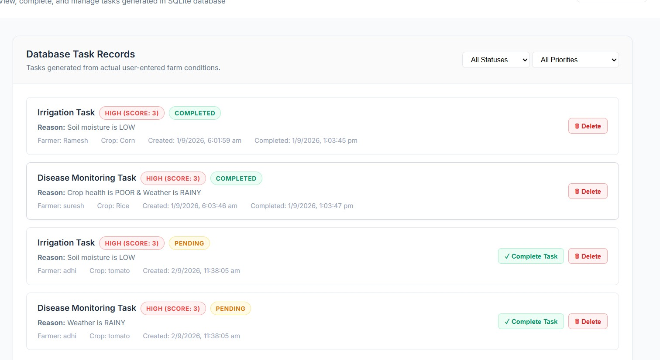
R Geethika – 192425101

B Nikhila – 192472102


